**Experiment:3**

**DATE: 09-08-2024**

**WRITING BASIC SQL SELECT STATEMENTS**

Find the Solution for the following:

1. True OR False

The following statement executes successfully.

Identify the Errors

SELECT employee_id, last_name sal*12 ANNUAL SALARY FROM employees;

Correction:

SELECT

employee_id,

last_name,

salary * 12 AS annual_salary

FROM

employees;

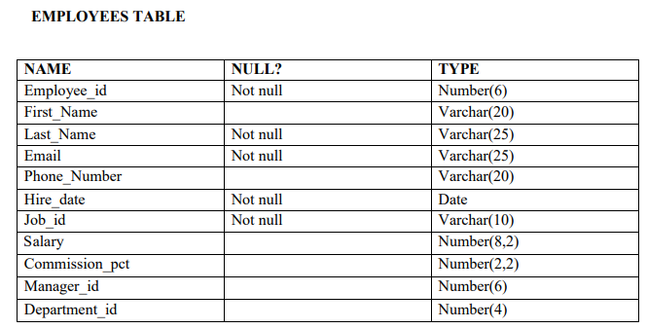

Queries

1. Show the structure of departments the table. Select all the data from it

CREATE TABLE EMPLOYEES (

Employee_id NUMBER(6) NOT NULL,

First_Name VARCHAR2(20),

Last_Name VARCHAR2(25) NOT NULL,

Email VARCHAR2(25) NOT NULL,

Phone_Number VARCHAR2(20),

Hire_date DATE NOT NULL,

Job_id VARCHAR2(10) NOT NULL,

Salary NUMBER(8,2),

Commission_pct NUMBER(2,2),

Manager_id NUMBER(6),

Department_id NUMBER(4),

CONSTRAINT emp_pk PRIMARY KEY (Employee_id)

);

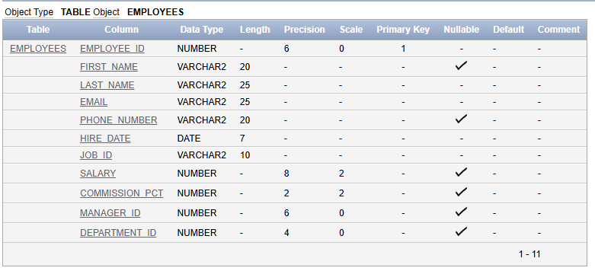

SELECT * FROM EMPLOYEES;

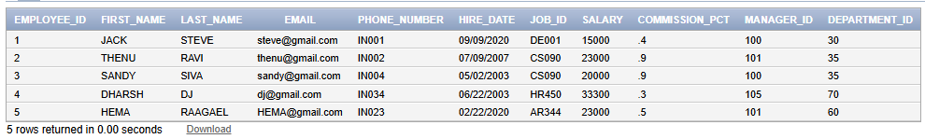

1. Create a query to display the last name, job code, hire date, and employee number for each employee, with employee number appearing first

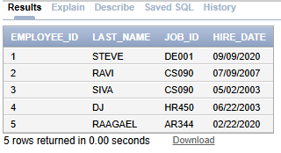

1. Provide an alias STARTDATE for the hire date.

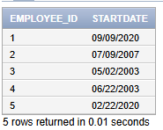

1. Create a query to display unique job codes from the employee table.



1. Display the last name concatenated with the job ID , separated by a comma and space, and name the column EMPLOYEE and TITLE.

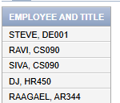

1. Create a query to display all the data from the employees table. Separate each column by a comma. Name the column THE_OUTPUT.

SELECT

Employee_id || ', ' ||

NVL(First_Name, '') || ', ' ||

Last_Name || ', ' ||

Email || ', ' ||

NVL(Phone_Number, '') || ', ' ||

TO_CHAR(Hire_date, 'YYYY-MM-DD') || ', ' ||

Job_id || ', ' ||

NVL(TO_CHAR(Salary), '') || ', ' ||

NVL(TO_CHAR(Commission_pct), '') || ', ' ||

NVL(TO_CHAR(Manager_id), '') || ', ' ||

NVL(TO_CHAR(Department_id), '') AS THE_OUTPUT

FROM

EMPLOYEES;

